ADHD Online Resources
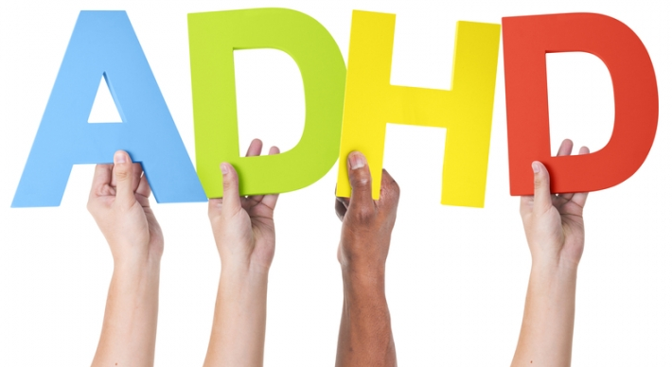
Attention deficit hyperactivity disorder (ADHD) - NHS (www.nhs.uk)

Home - ADHD Foundation : ADHD Foundation

Kids With ADHD: What It Feels Like (verywellmind.com)

ADHD UK | ADHD UK

ADHD and mental health - Mind

Online Resources | ADHD Virtual Help (adhdcare.co.uk)

Overcoming Every Sleeping Challenge For Kids With ADHD (adhdcentre.co.uk)

ADHD Diet and Nutrition: Foods To Eat & Foods to Avoid (webmd.com)
