- - Ten things in a ?’s pocket
Compost from last week
Gardening gloves receipt
Key to the greenhouse
A handle from a broken shovel
Twenty empty seed packets
A back up hat
A bill for the spade
A few seeds at the bottom
Bits off a broken plant pot
A pair of scissors
Whose pocket do you think this is?

- - A handful of frogs
A couple of boiled sweets
A bendy wand
A large, black cauldron
Six brown mice
A big book of magic spells
17 bat wings
1 tabby kitten
Whose pocket is this?
3 - Multiple Bolts
Spanners of all sizes
Keys
Oil cans
Never-ending supplies of petrol
Wires and cables
Magic brave dust
Healing plaster
Shock absorbers
Wheels
Whose pocket is this?

4 - An oval ball
A gum shield
A large amount of courage
Heaps of bravery
A world-cup trophy
Gold medals
Team spirit
A coach’s encouraging words
Whose pocket is this? 5 – see below
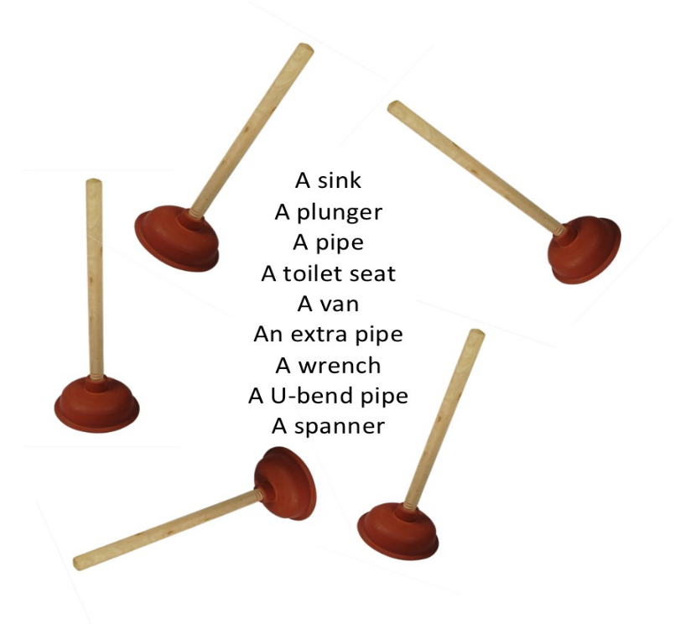
6- a small hand-gun
A sharp, bloodied knife
A heavy baseball bat
A ripped up criminal record
A tiny lockpick
A glossy metal hammer
An evil urge

Answers

Gardener
Witch
Stunt – driver
Rugby player
A plumber
A thief

