Due to school closures, declining pupil numbers, staff shortages and supply chain issues, Dolce will be implementing an emergency menu from Monday 23rd March 2020.
All pre orders in place will be cancelled after Friday 20th March.
Our catering teams have been advised to use up as much perishable stock as they can this week to avoid wastage, some small changes to menus may be seen for the remainder of the week.
The menu being offered on an emergency basis is simplified in comparison to our usual menus, but still offers hot and cold food options, vegetables, salad and a selection of desserts.
If you would like your child to have a school dinner from Monday 23rd March, please send your order into school by 1pm tomorrow, Thursday 19th March. We appreciate this is a very tight deadline, but our cook needs to place food orders on Friday to ensure she has the correct ingredients to provide these meals.
The options available to you are:-
1. Pre-order a meal by tomorrow
2. Do not pre-order a meal and your child will be given what we have
3. Your child brings a packed lunch from home
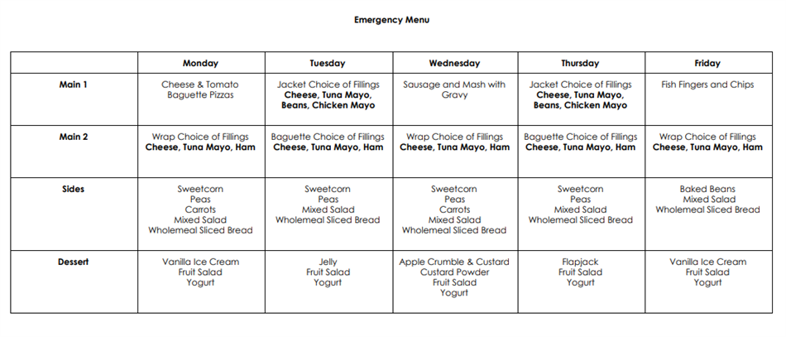

Go to the page-top

