For the parents who were unable to attend the PSHE meeting last week, the following was shared and discussed: (for Copyright reasons I am not able to share the powerpoint on the website)
We aim to inform you of:​
- The school’s legal obligations on Relationships, Sex and Health Education (from 2020)​
- What we mean by Sex Education​
- Your rights as a parent/carer​
- How, what, why and when we intend to teach children

What can school lessons provide for your children?
- Safeguarding​
- Accurate information – e.g. names for body parts​
- Safe and supportive environment​
- Chance to ask questions ​
- Chance to discuss common issues and worries​
- Chance to see and celebrate what are normal, healthy, respectful relationships​
- How to recognise when relationships are not healthy​
- Where to find out more​
- Where to get help

Compulsory status of RSE and Health Education
In 2017 the government passed an amendment to the Children and Social Work Bill to make RSE and Health Education statutory from Sept 2020.​
​
Supported by over 100 organisations, including Public Health England, Teaching Unions, NCB, etc.​
​
Ratified by House of Lords 24 April 2019

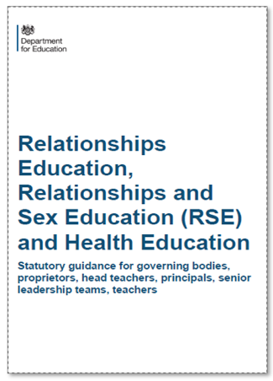

What have schools got to teach?
PRIMARY​
RELATIONSHIPS EDUCATION IS COMPUSLORY​
HEALTH EDUCATION IS COMPULSORY​
But Sex Education is at school’s discretion
What are the statutory expectations of Relationships Education?
- Families and people who care for me ​
- Caring friendships​
- Respectful relationships​
- Online relationships​
- Being safe

‘Today’s children and young people are growing up in an increasingly complex world and living their lives seamlessly on and offline….children and young people need to know how to be safe and healthy, and how to manage their academic, personal and social lives in a positive way’​
DfE Guidance on Relationships Education, Sex Education and Health Education 2019

LGBT+Equality

‘Schools are required to comply with relevant requirements of the Equality Act 2010. Further guidance is available for schools in The Equality Act 2010 and schools advice. Schools should pay particular attention to the Public sector equality duty (PSED) (s.149 of the Equality Act).’ - Para 27 page 13​
​
‘Schools should be alive to issues such as everyday sexism, misogyny, homophobia and gender stereotypes and take positive action to build a culture where these are not tolerated, and any occurrences are identified and tackled.’ - Para 31 page 13

What are the statutory expectations for Health Education?
- Mental wellbeing​
- Internet safety and harms​
- Physical health and fitness​
- Healthy eating​
- Drugs, alcohol and tobacco​
- Health and prevention​
- Basic First Aid​
- Changing adolescent body (Puberty)

What should children know about puberty?
(This is statutory in Health Education and parents cannot withdraw their children from it)​
- Correct names for parts of the body, including genitalia​
- How their bodies will change during puberty​
- How to manage these changes / practicalities​
- Why these changes need to happen​
- How and where to ask for help if needed

What is Sex Education?

Our scheme is about human reproduction.

Is there any Sex Education in KS1 Science?
- identify, name, draw and label the basic parts of the human body and say which part of the body is associated with each sense​
​
- notice that animals, including humans, have offspring which grow into adults
Sex Education in KS2
- describe the differences in the life cycles of a mammal, an amphibian, an insect and a bird ​
- describe the life process of reproduction in some plants and animals​
- describe the changes as humans develop to old age​
- learn about the changes experienced in puberty

Legally:​
- Schools MUST teach the Science curriculum​
- Schools MUST teach Relationships and Health Education (including changing adolescent body)​
​
Plus…​
a ‘recommendation’ that all schools have a Sex Education Programme ​

Can parents withdraw from RSE?
“Parents have the right to request that their child be withdrawn from some or all of sex education delivered as part of statutory RSE”.​
NOT from Relationships or Health Education.

What is Jigsaw?

A whole-school PSHE Programme comprising:​
- A comprehensive and completely original scheme of work (lessons) for ages 3 to 16​
- PSHE (Personal, Social, and Health Education) includes statutory Relationships and Health Education​
- A detailed weekly lesson plan for all year groups, including all teaching resources​
- The Jigsaw Approach, underpinned by mindfulness​
- Assemblies, Jigsaw Friends, Jigsaw Chimes, original music and songs, Jigsaw Jerrie Cat

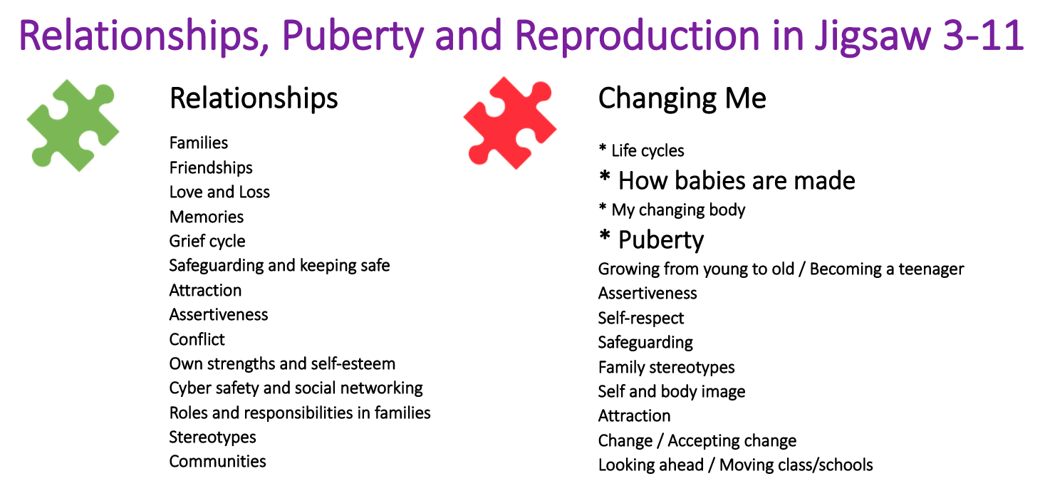

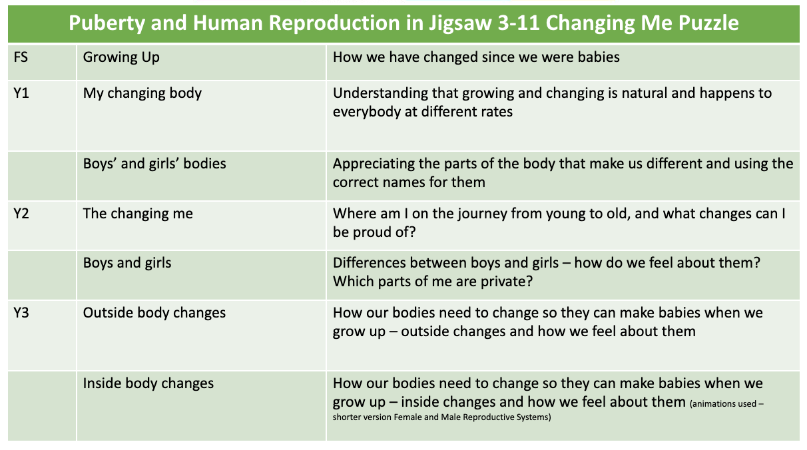

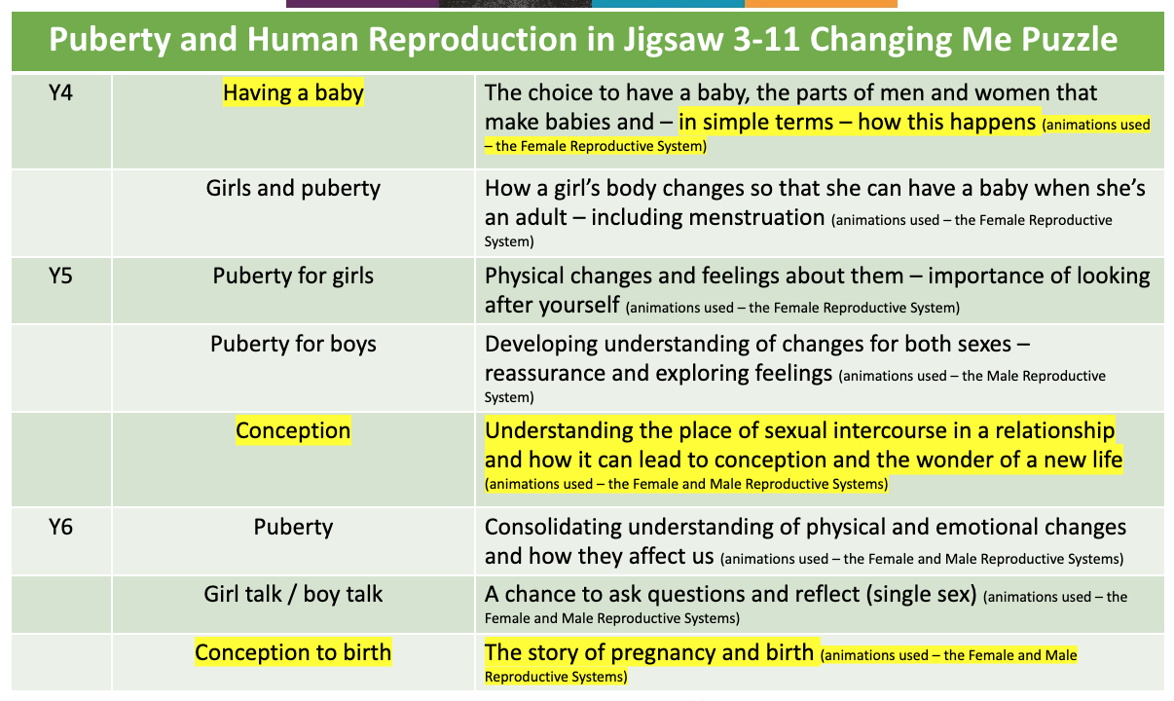

Our intention this year is to teach the year groups separately in Year 3 and 4. If you would like copies of the lesson plans and specific slides used then please contact Mrs Acheson directly at headteacher@gfschools.co.uk

At Fountains, the lessons will take place on the afternoon of Wednesday 6th July for Years 3 and 4 and Mrs Barker will confirm the date for Years 5 and 6 in the coming days.

At Grewelthorpe, dates for Y3/4 will be confirmed shortly and the Year 5 and Year 6 sessions will be on Friday 1st July.

