Harvest Services
Grewelthorpe Church

Sunday Oct 10th 10.30am
Harvest Festival
with the school children

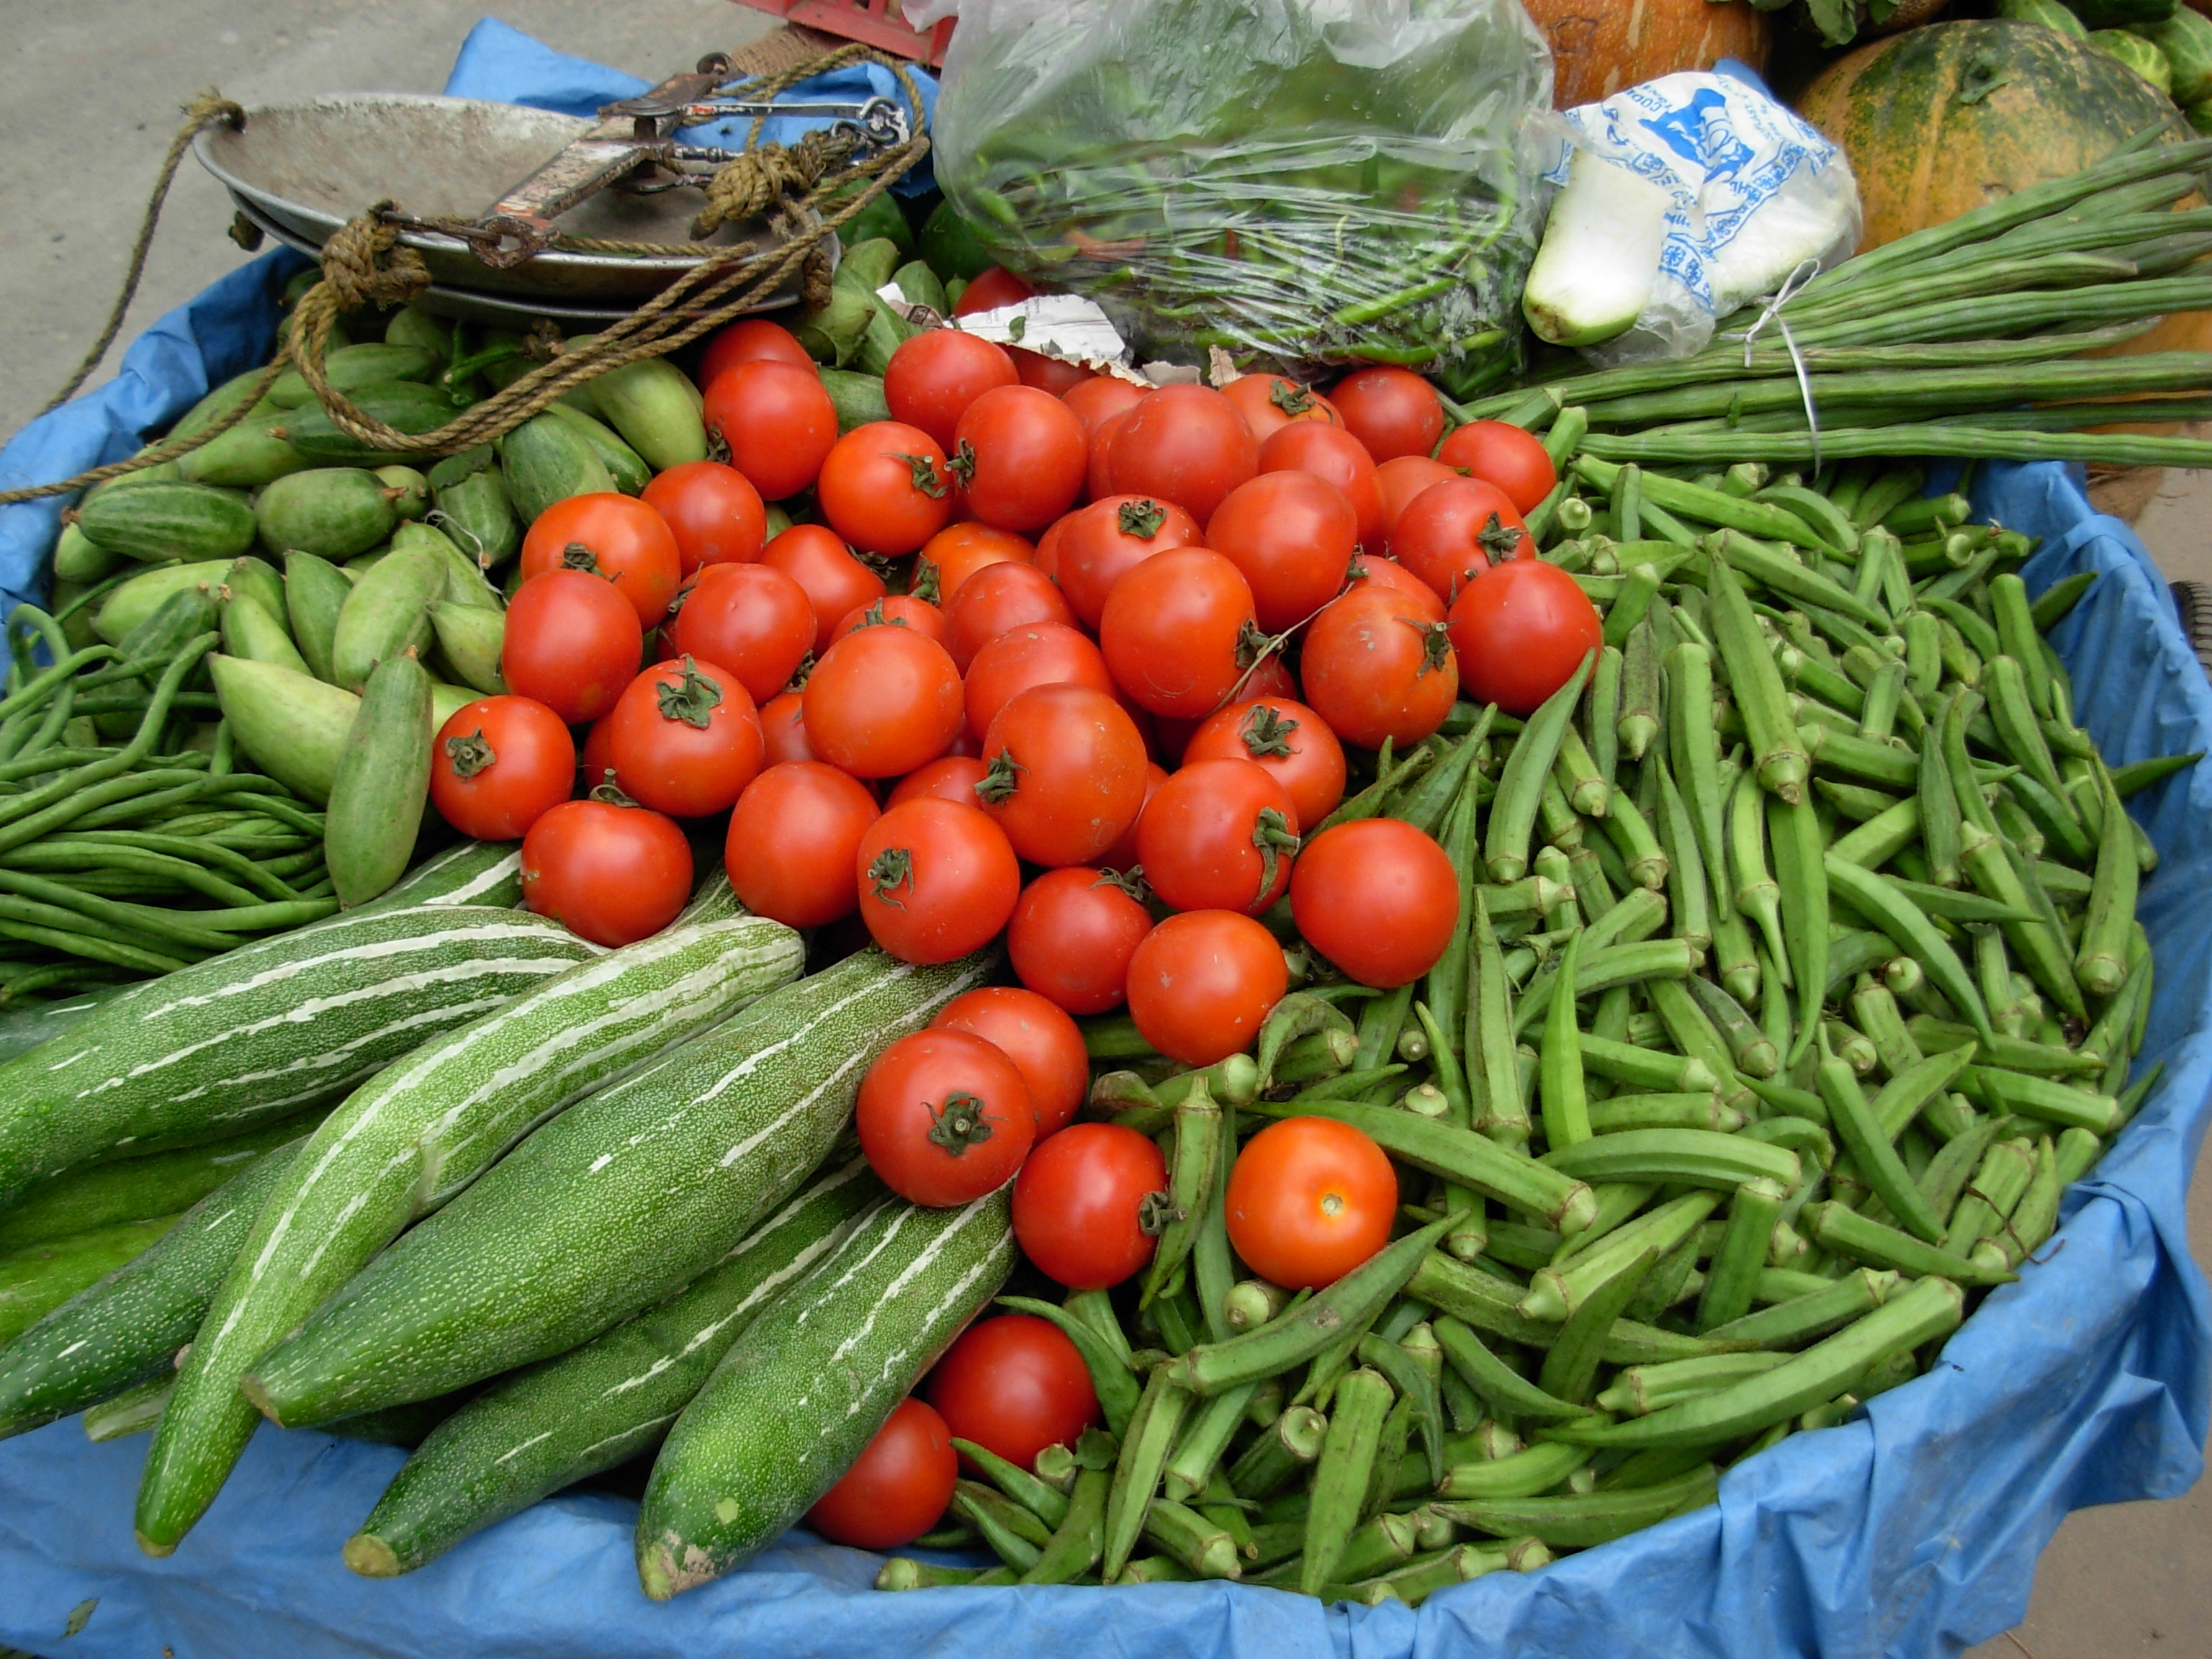
Tuesday 12th Oct. at 7.00pm
Harvest Thanksgiving
Service, Supper and Sale
with Rev. Leslie Newton

Please come and join us

