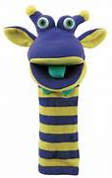
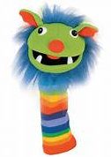
Sockettes Sing & Speech Group

A fun group session, for children aged 3 - 4 years, accompanied by Parents / Carers

Venue: Harrogate Library, Victoria Avenue, Harrogate, HG1 1EG

Dates: Tuesday afternoons for a 45 minute session 2:00 pm to 2:45 pm

for 7 weeks: January 16th, 23rd, 30th, February 20th, 27th & March 5th, 12th.

Come have fun with music, rhyme, & rhythm activities to help develop speech sound skills in readiness for school
Groups are free & will be run by a Speech and Language Therapist & Assistant from the NYC SEND Hub Communication & Interaction Team
Limited to 8 children per group
A Baseline Assessment of your Child’s speech sounds will be taken along with parent/carer voice feedback
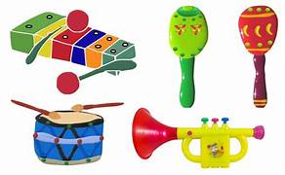
To book your child’s place please contact Carol Moxon: Carol.Moxon@northyorks.gov.uk

We look forwards to seeing you

