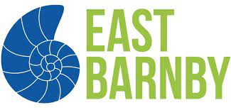
SANDWICH CHOICE LIST
Your child will require a packed lunch to take with them during the day. Please indicate their choice of sandwich and return to school by Monday 2nd May.

 | CHEESE | HAM | EGG | TUNA
MONDAY
TUESDAY
WEDNESDAY

