Music Successes

This year Mrs Johnson celebrated teaching in Ripon for 25 years with a concert at Holy Trinity Church. She was joined by students past and present including a few from Grewelthorpe School.
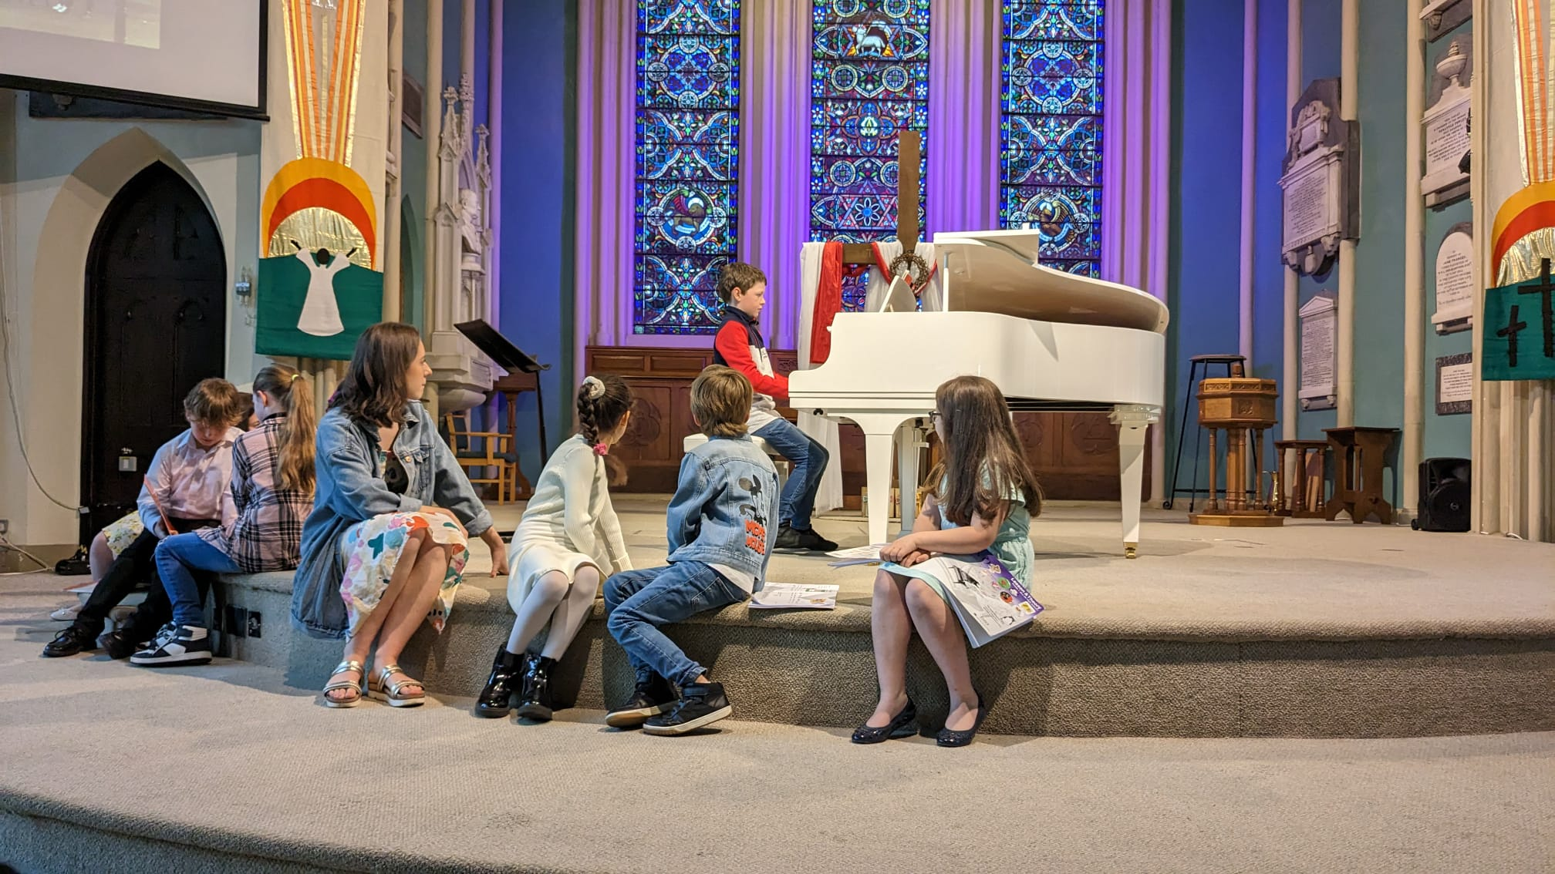
In exam news, the boys in class 3 were very excited to get their certificates. Three of them had taken their Initial Grade piano exam and also a grade 1 singing.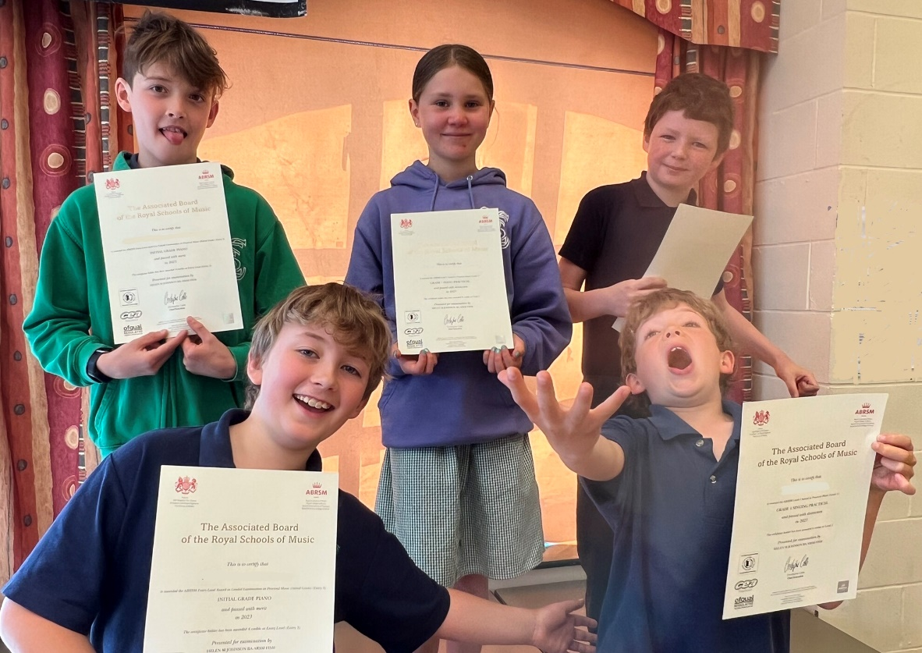 The Y6 girls were very pleased to take their Grade 1 piano before they moved on to their new school. Everyone did brilliantly and passed with merits and distinctions.
