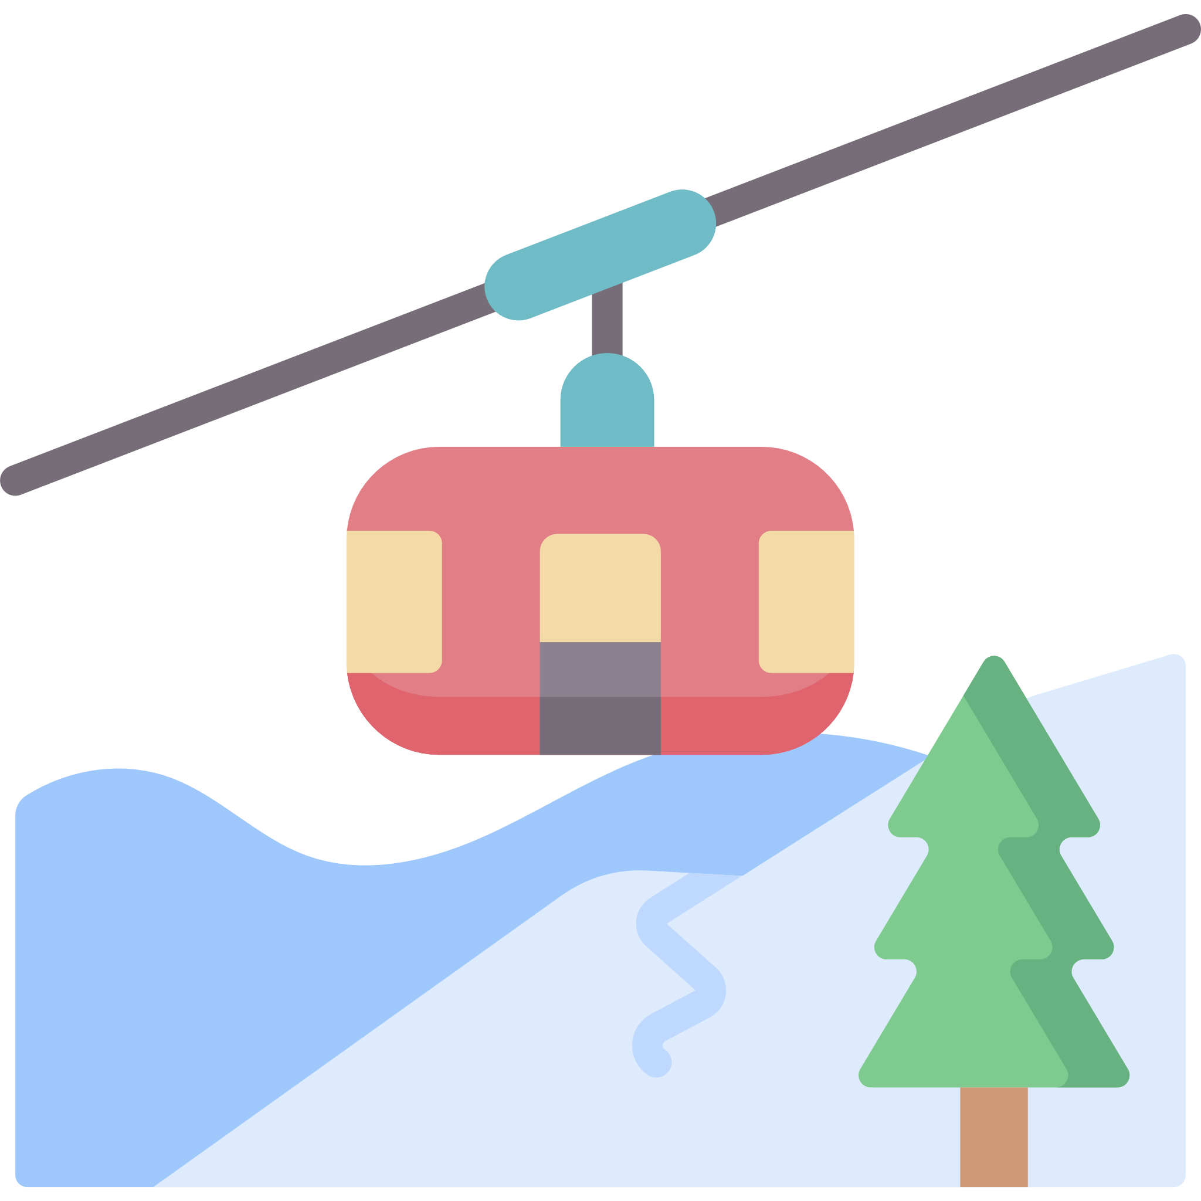

**Setting Description**

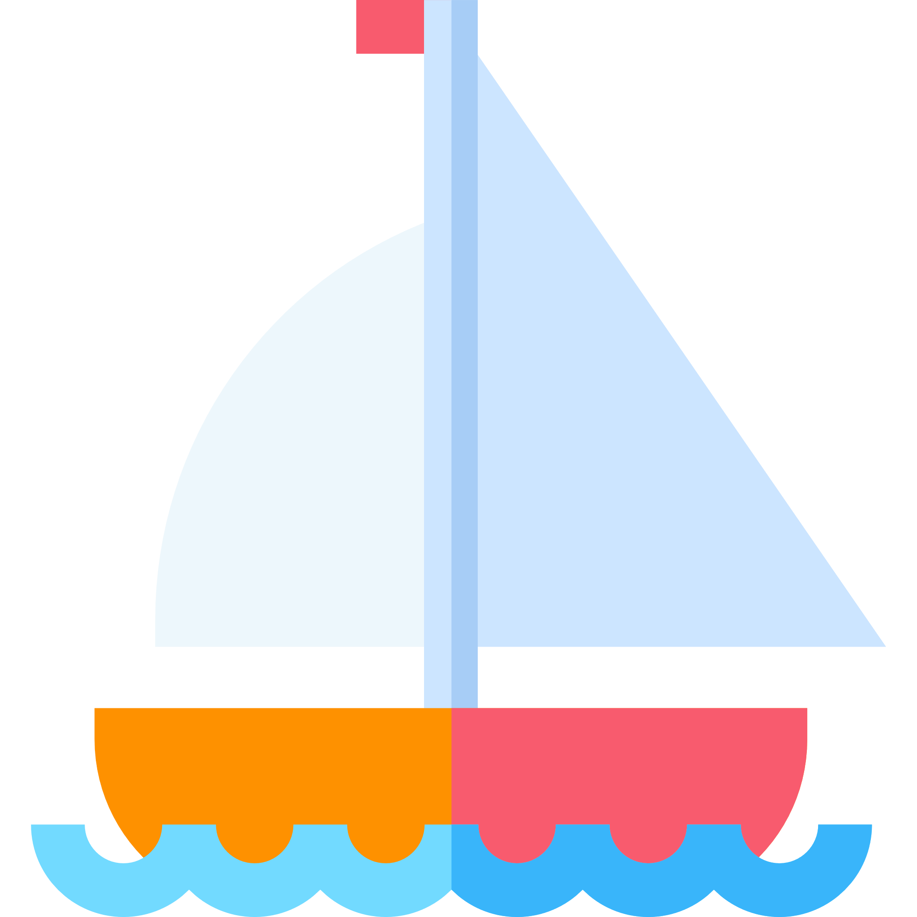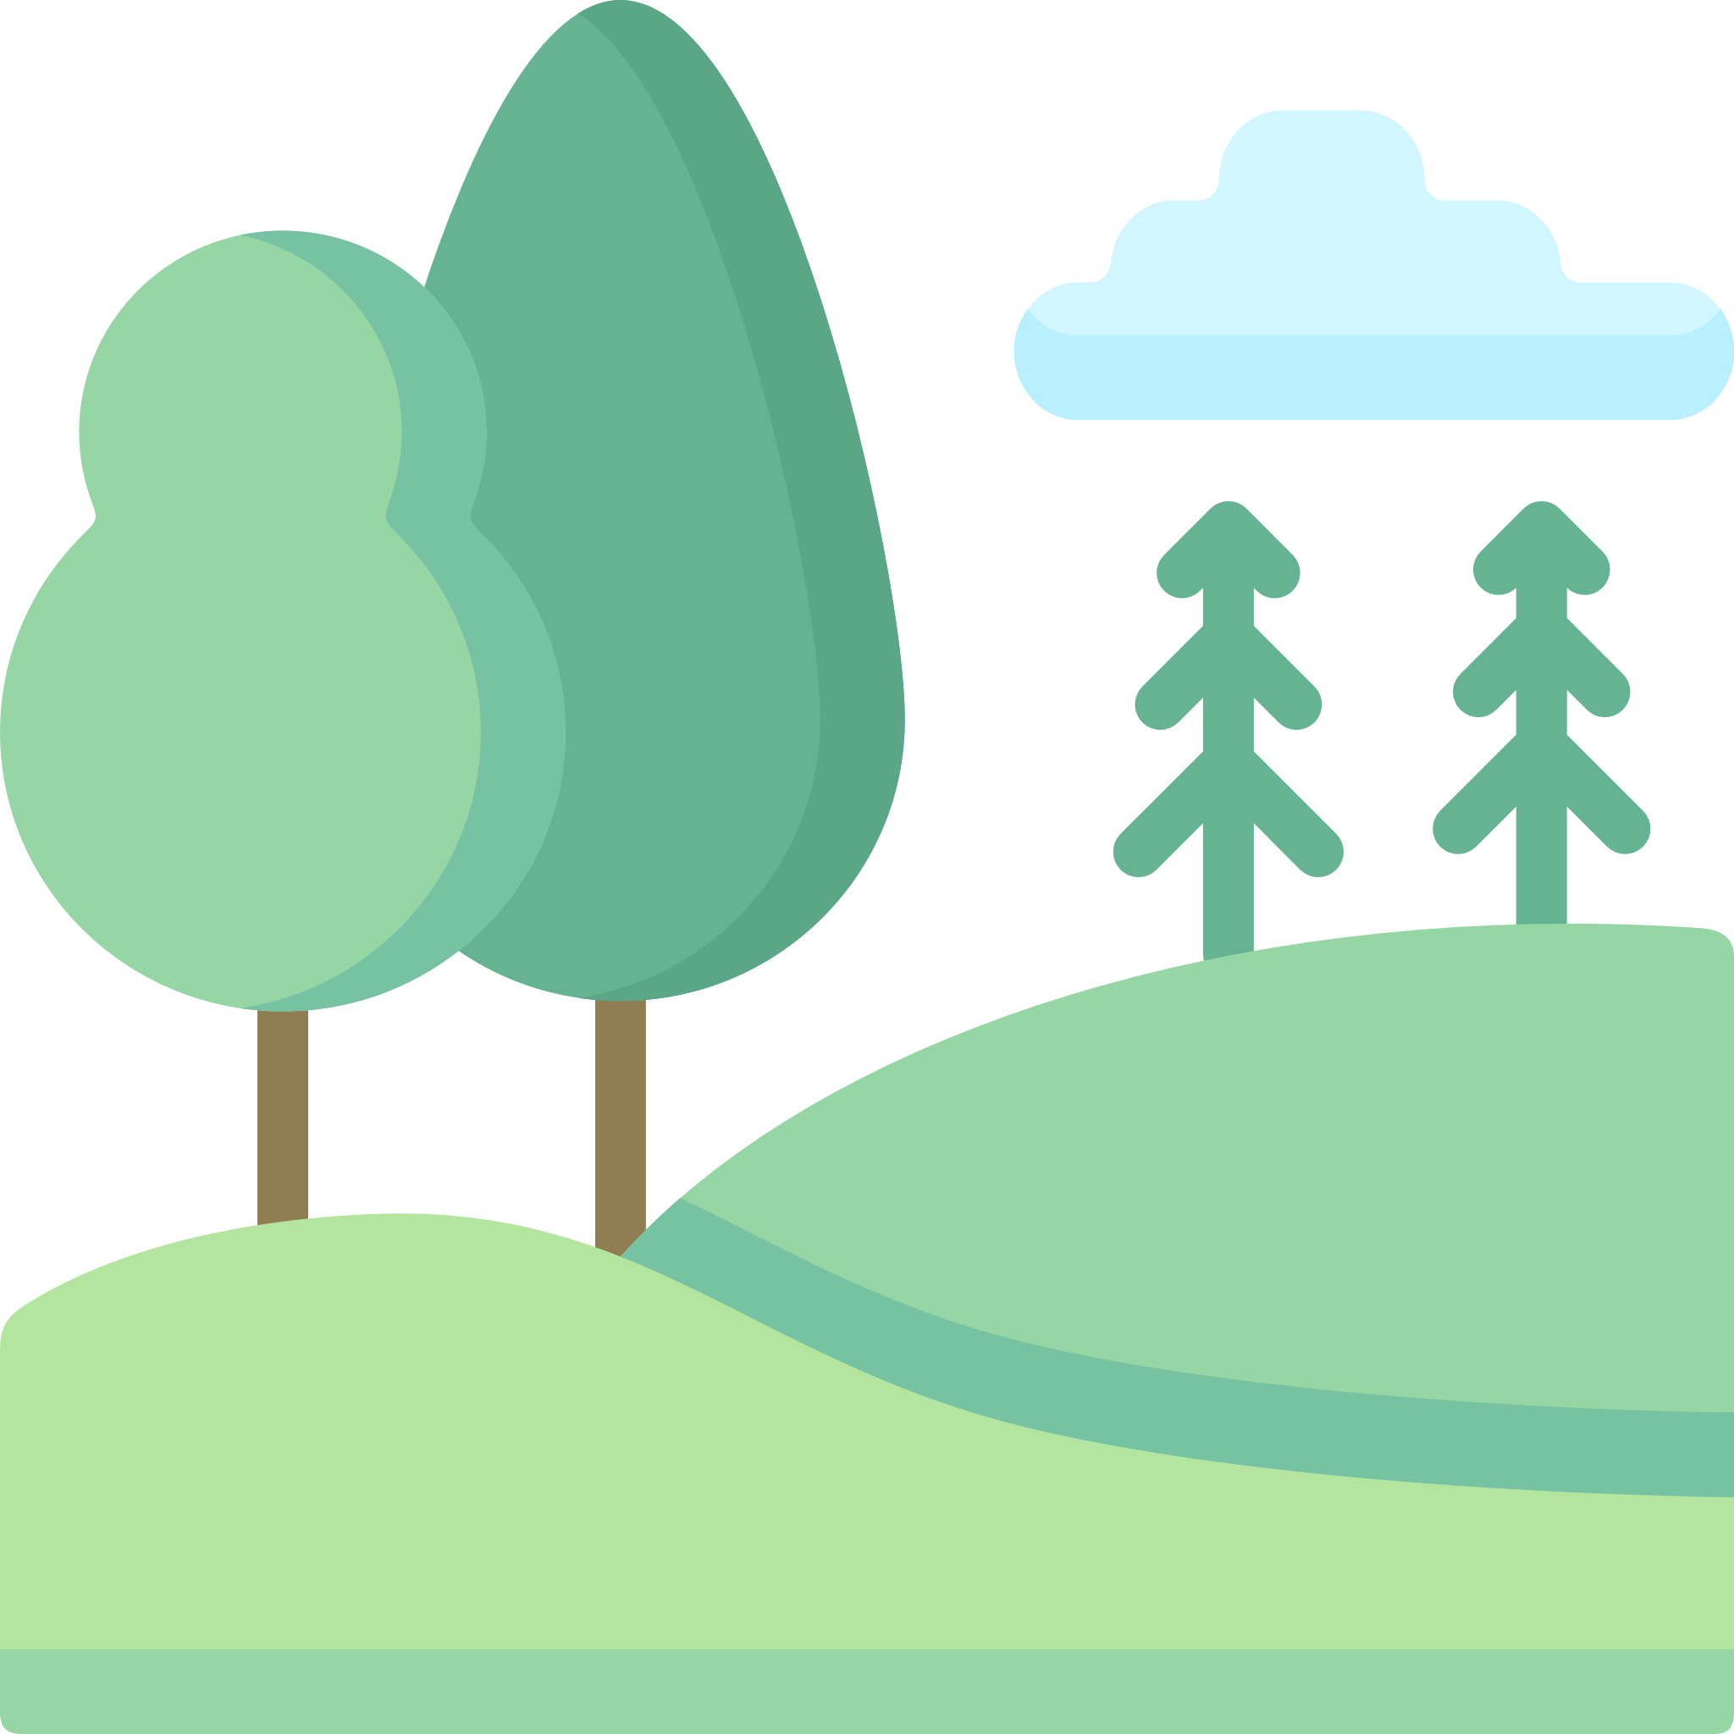

**Draw a picture of your setting too!**

_________________________________________________________________________________________________________________________________________________________________________________________________________________________________________________________________________________________________________________________________________________________________________________________________________________________________________________________________________________________________________________________________________________________________________________________________________________________________________________________________________________________________________________________________

Imagine you could choose to go on holiday anywhere in the world. Close your eyes and try to visualise your holiday destination.

* Where is it? The coast, mountains, forest, sea?
* What can you see?
* What can you hear?
* What can you smell?
* How do you feel?

Use your ideas to write a setting description. Make sure you include detail so that whoever reads your description feels like they are actually there!