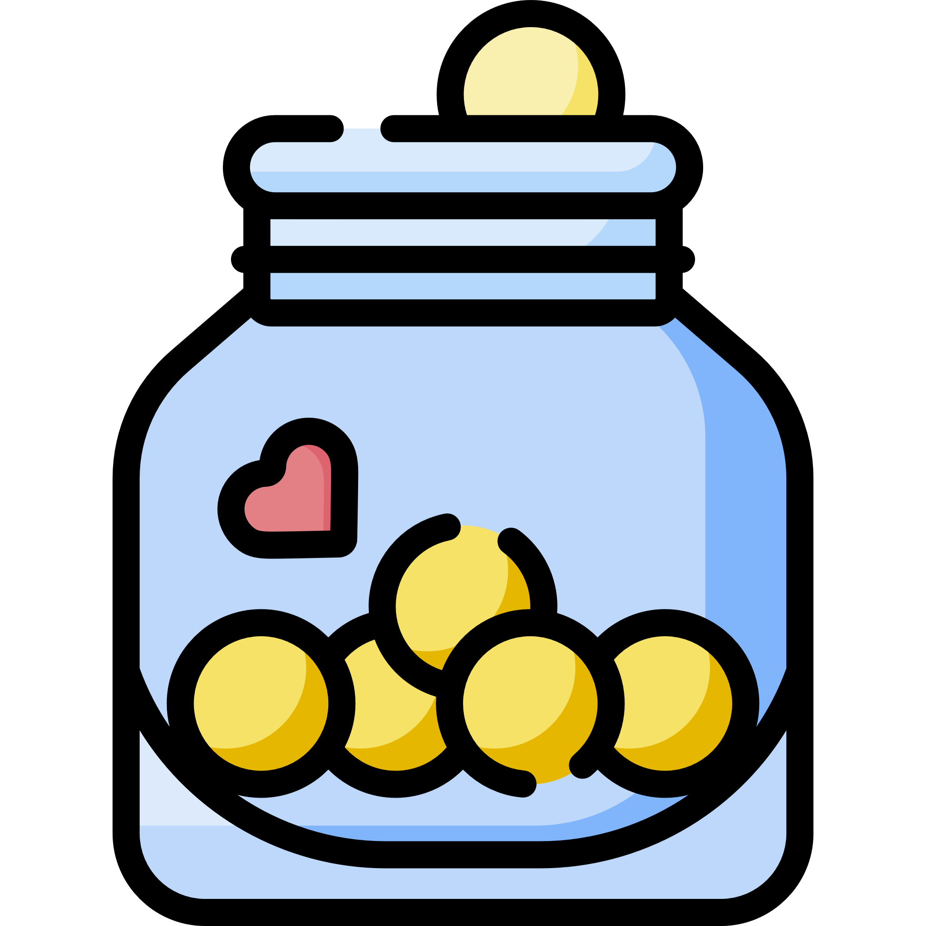

Money Box Design

A money box is a place where we keep our money. It stores it until we are ready to spend it or put it somewhere else, like a bank account so we can continue to save.

* Do you have a money box, or have you seen one before?

Draw a money box design. Think about:

* Will you have a coin slot?
* How will you get the money out of your money box?
* What colours, shapes, patterns will you use?



What materials will you use? E.g. card, old containers or boxes?

How will you make your money box? Paint, draw, glue?

Make your money box and use it to look after your money!