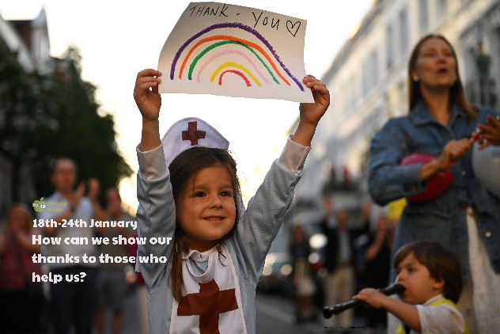 

Read and research to find out how other countries have celebrated their heroes throughout the pandemic.

Use ‘Home resource 1’ to describe a time when somebody clapped for you. When was it? Where were you? Why did they clap? Who clapped for you? Did you enjoy being clapped for? How did it make you feel?

Use ‘Home resource 2’ to answer some maths word problems linked to ‘Clap for Carers and Heroes’.

The girl in the picture is holding a rainbow. The rainbow has come to be a symbol of hope during lockdown. Either make a rainbow or create your own symbol of hope. Choose whether to use crayon, chalk, paint or material.

Think about somebody who has been your hero this year. Explain who they are and why they are your hero by writing a paragraph, creating a fact file or drawing a picture of them.

Have a go at clapping. Can you describe what it sounded like? Was your clap slow or fast? Loud or soft? Does your clap have a steady beat? Does your clap have a rhythm? Do you think how you clap can mean different things? Discuss how a loud, fast and enthusiastic clap might show that you really like something or have really enjoyed it. Explain we can also use our hands to compose a piece of music. Explore other ways your hands can make a sound e.g. clicking, rubbing, using them to tap other body parts. Create your own piece of clapping music!

**Learning from home**

Use the ideas below, alongside this week’s resource, to support your home learning.