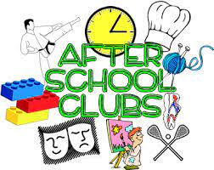
AFTER SCHOOL CLUBS AUTUMN TERM
WEEK COMMENCING 13TH SEPTEMBER – WEEK ENDING 22ND OCTOBER
Dear parent/Carers
After school clubs will initially run for the first half term, 6 weeks.
Clubs run from 3.30 pm – 4.30 pm at a cost of £3.50
 | CLUB | CLASS
MONDAY | ART & POTTERY – MRS LYALL
TUESDAY | MIXED FOOTBALL – MR WHITFORD | 3 & 4
WEDNESDAY | FIDDLE – MRS HICKINGBOTHAM | 2, 3 & 4
THURSDAY | COOKERY – MRS SPOWART | 2, 3 & 4

If you would like your child to attend any of the clubs, please fill in the booking form below and return to the office.

 | CLUB | 1ST CHILD | 2ND CHILD | 3RD CHILD
MONDAY | ART & POTTERY | TO BE BOOKED DIRECTLY WITH MRS LYALL  DETAILS ON THE WEBSITE
TUESDAY | FOOTBALL
WEDNESDAY | FIDDLE
THURSDAY | COOKERY

CLUB | YEAR GROUP | SPACES AVAILABLE
MIXED FOOTBALL | YEAR’S 3, 4, 5 & 6 | 20 SPACES
FIDDLE | YEAR’S 2, 3, 4, 5 & 6 | 10 SPACES
COOKERY | YEAR’S 2, 3,4, 5 & 6 | 8 SPACES AVAILABLE
Spaces will be allocated on a first come first served basis.

SIGNED: ………………………………………………………………………… DATE: ………………………………………………

