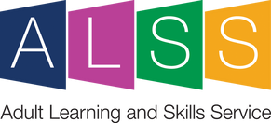
Do you need to improve your computer skills? Maybe a friend or member of your family needs some help getting online? Perhaps you have the basics, but would like to learn how to use Excel spreadsheets?
FREE Face to Face Computer Courses
Ripon Community House, Allhallowgate

It's not too late to join our beginners' computers and introduction to Excel spreadsheets courses running every Friday until 14 October in Community House, Ripon.
First Steps with Computers - 09.30 - 11.30.
This 5 -week course will provide a hands-on introduction for those who are completely new to using a computer.
Get started with spreadsheets (MS Excel) - 12.00 - 15.00
An introduction course for those new to Excel spreadsheets. You will need basic computer skills and will learn how to create, edit and save a spreadsheet safely.

Call us on 01609 536066 to secure your place.
For more information visit our Computing and Getting Online courses https://ebsontrackprospect.northyorks.gov.uk/page/findcourse
Call our Adult Learning Team on 01609 536066
Email: adultlearnin@northyorks.gov.uk

