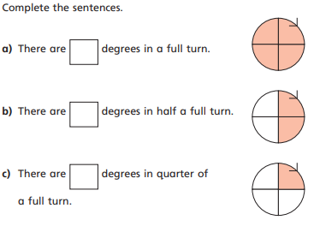
1.

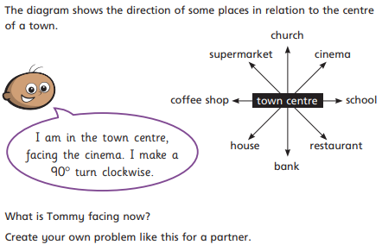
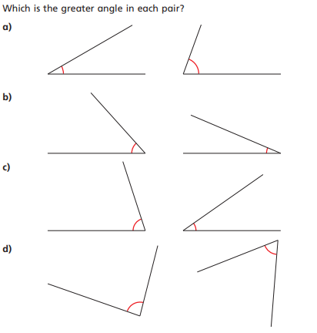
2.

3.
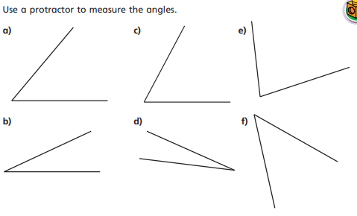
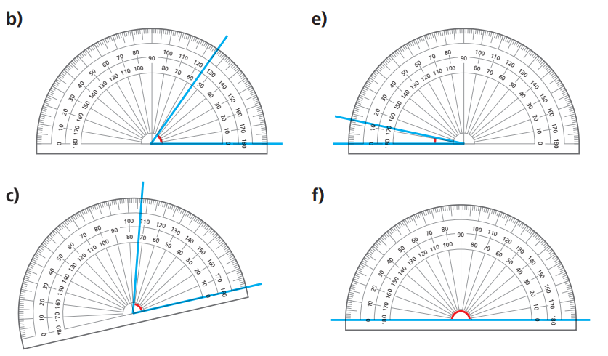
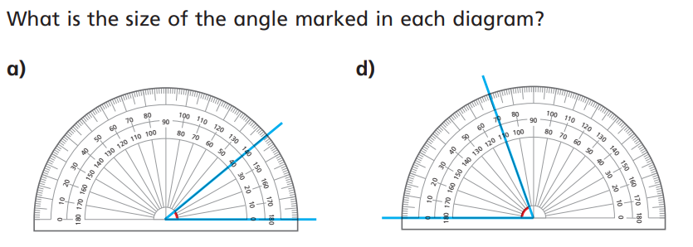
4.
5.

Problem Solving 3
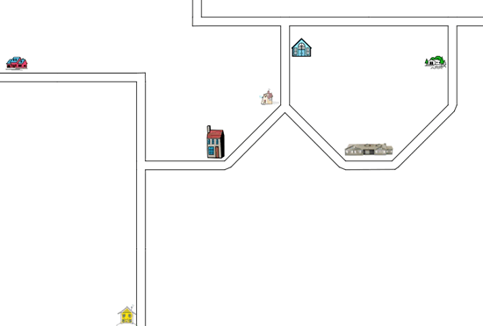
There are six places to visit:
1. Relations who live in the tall house;
2. Friends who live in the house with trees;
3. The wide school building;
4. The blue church;
5. The health centre with blue roof and pink walls;
6. The little pink shop which is leaning over.
You live in the yellow house at the bottom of the map.
Starting at your house, try to describe the journey to each of the six places.
You'll need to describe the bends in the road - how much they turn in degrees - and which way to turn at junctions.

Problem Solving 4
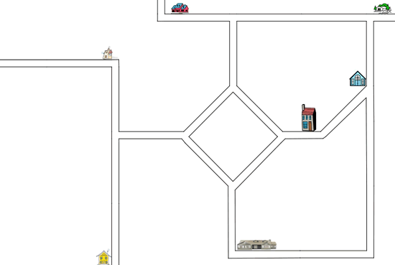
There are six places to visit:
1. Relations who live in the tall house;
2. Friends who live in the house with trees;
3. The wide school building;
4. The blue church;
5. The health centre with blue roof and pink walls;
6. The little pink shop which is leaning over.
You live in the yellow house at the bottom of the map.
Starting at your house, try to describe the journey to each of the six places.
You'll need to describe the bends in the road - how much they turn in degrees - and which way to turn at junctions.

