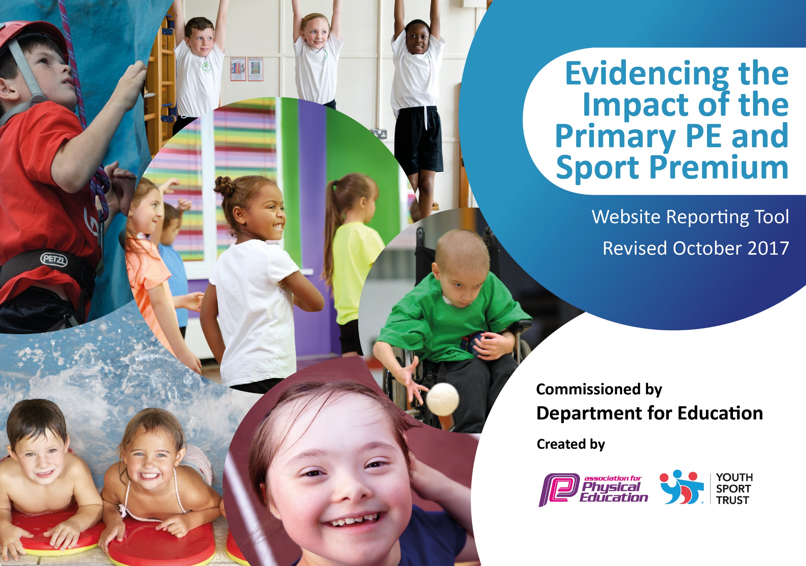

Schools must use the funding to make additional and sustainable improvements to the quality of PE and sport they offer. This means that you should use the Primary PE and Sport Premium to:

- develop or add to the PE and sport activities that your school already offers
- build capacity and capability within the school to ensure that improvements made now will benefit pupils joining the school in future years

Please visit gov.uk for the revised DfE guidance including the 5 key indicators across which schools should demonstrate an improvement. This document will help you to review your provision and to report your spend. DfE encourages schools to use this template as an effective way of meeting the reporting requirements of the Primary PE and Sport Premium.

We recommend you start by reflecting on the impact of current provision and reviewing the previous spend.
Under the Ofsted Schools Inspection Framework, inspectors will assess how effectively leaders use
the Primary PE and Sport Premium and measure its impact on outcomes for pupils, and how effectively governors hold them to account
for this.

Schools are required to publish details of how they spend this funding as well as on the impact it has on pupils’ PE
and sport participation and attainment.
We recommend regularly updating the table and
publishing it on your website as evidence
of your ongoing review into how you are using the money
to secure maximum, sustainable impact. To see an example of how to complete the table please click HERE.

Support for review and reflection - considering the 5 key indicators from DfE, what development needs are a priority for your setting and your students now and why? Use the space below to reflect on previous spend, identify current need and priorities for the future.

Key achievements to date: September 2018 | Areas for further improvement and baseline evidence of need:
So far all children have taken part in Level 2 competitions, and some children have taken part at Level 3.  Children have taken part in a wide range of activities. We took part in 15 events last year.  Children have tried new activities (cycling, archery and golf).  New members of staff have been given training in the implementation of Real PE.  PE lead has been allowed release time to attend training courses, and has also been allowed time to network with other leaders in the area.  Children have done very well with swimming, and 100% of Year 6 pupils are able to swim 25m, and looking forward we are predicted the same figures next year too.  The celebration of PE and sporting success is embedded across school, with special assemblies having taken place to award trophies and talk about the children’s success. | Expand and increase opportunities for intra sport competitions. Aim to provide one per half term on a different sport each time.  Baseline evidence of need is collected through the Koboca survey every November and impact measured through an additional survey in the summer term.  Results have been obtained and children have been identified and highlighted to teachers to encourage joining and participation in active activities.  Introduce with an assembly; introduce different zones and games children can access in lunchtimes and playtimes.  Quick impact and activity indicator to be used in classrooms for teachers to show the activity children have done.  MSAs to be given training by PE specialist to help promote games and activities at lunchtime.  To ensure that all teaching staff are confident when teaching PE.

Meeting national curriculum requirements for swimming and water safety | Please complete all of the below:
What percentage of your Year 6 pupils could swim competently, confidently and proficiently over a distance of at least 25 metres when they left your primary school at the end of last academic year? | 100%
What percentage of your Year 6 pupils could use a range of strokes effectively [for example, front crawl, backstroke and breaststroke] when they left your primary school at the end of last academic year? | 100%
What percentage of your Year 6 pupils could perform safe self-rescue in different water-based situations when they left your primary school at the end of last academic year? | 100%
Schools can choose to use the Primary PE and Sport Premium to provide additional provision for swimming but this must be for activity over and above the national curriculum requirements. Have you used it in this way? | No

£16 650 expected.
Action Plan and Budget Tracking
Capture your intended annual spend against the 5 key indicators. Clarify the success criteria and evidence of impact that you intend to measure to evaluate for students today and for the future.

Academic Year: 2018/19 | Total fund allocated: £ | Date Updated: September 2018
Key indicator 1: The engagement of all pupils in regular physical activity – Chief Medical Officer guidelines recommend that primary school children undertake at least 30 minutes of physical activity a day in school |  |  |  | Percentage of total allocation:
 |  |  |  | %
School focus with clarity on intended impact on pupils: | Actions to achieve: | Funding allocated: | Evidence and impact: | Sustainability and suggested next steps:
Improve physical activity levels in our most inactive pupils.  Look at providing additional lunchtime clubs for pupils to access their 30 minutes of physical activity. Engage the least active pupils in meaningful activity and give them the confidence to move on to regular extra-curricular and community clubs to ensure lifelong participation.  Ensure maximum uptake of extra-curricular clubs to engage as many pupils in extra- curricular physical activity as possible.  Purchase of equipment/resources  Structured calendar of non-competitive sports events including the Change4Life scheme.  Employment of a Forest School teacher one afternoon per week, and 1 member of staff to attend training on forest schools and work with the Forest School teacher. | All pupils in school to take survey to identify physical activity levels and activities they would like to try.  Utilise PE Specialists to deliver lunchtime clubs to target the least active pupils.  Actively encourage target group to engage in an extra-curricular club. Utilise PE Specialists to deliver popular clubs that will engage the children.  Pupils to go on to take part in other extra-curricular clubs-gardening to develop an understanding of healthy eating.  £1500 budget to renew and add to equipment including appropriate kit  Within HSSP membership  Cost of teachers is £75 per afternoon  Cost of training course £450 x1 staff. | N/A  £25 per hour  2 lunchtimes per week 38 weeks £1900.  Cost of club activities for targeted pupils 12 weeks £3.50 per week 6 children £252  £1500  HSSP cost £1300  £3000  £450 | Engage pupils not meeting the CMO guidelines by providing activities they have requested.  Lunchtime Clubs to be set up to target the least active pupils.  An increased proportion of target children will attend after school clubs.  More active curriculum for all pupils across all subjects.  Increased pupil participation. Positive attitudes to health and well-being.  Improved behaviour and attendance and reduction of low-level disruption  Easier pupil management  Development of pupil ownership and involvement in school sports. | Look in to buying and using Kobocca to help with data capture and to identify key areas for improvement.  Complete survey twice a year to allow us to continuously monitor physical activity levels and identify the most appropriate target groups to achieve maximum impact.  To ensure Midday supervisors are involved in lunchtime clubs to allow them to be continued without PE Specialists.  PE lead to lead an after-school club.  Equipment will enable activities to take place not just in lessons but at playtimes and after school.  Participating in regular sporting events creates a culture of sport and an ongoing expectation.  Listening to the children’s views and interests in sport will increase engagement in this area.

Key indicator 2: The profile of PE and sport being raised across the school as a tool for whole school improvement |  |  |  | Percentage of total allocation:
 |  |  |  | %
School focus with clarity on intended impact on pupils: | Actions to achieve: | Funding allocated: | Evidence and impact: | Sustainability and suggested next steps:
Develop pupils’ social skills and facilitate their involvement in making a contribution to their community.  Develop and enhance leadership, communication and organisation skills in young people by forming a School Sports Crew.  Build confidence and feeling of belonging to the school through ensuring all pupils represent the school in some form.  Use PE and Sport to impact cross curricular. Engage disengaged pupils through using PE as a tool to deliver other subjects  The use of school games and YST awards to evaluate the sport and PE.  The use and promotion of School Games Sporting Values: honesty, respect, teamwork, passion, self-belief and determination | Identify pupils from survey who are not members of community clubs and facilitate their transition to a community club, whether as a player or volunteer.  PE lead to set up a School Sports Crew.  Use survey results to identify pupils who have not represented the school in the last year and facilitate their involvement.  Access YSSN cross curricular programme in nutrition, science, English and geography.  Within HSSP membership  Within HSSP membership | N/A  PE lead cover £300.  HSSP.  Within the HSSP  N/A  N/A | More children are part of community sports clubs.  Playground activities delivered at lunchtimes by members of the SSC.  10% increase in pupils competing for school team.  Improved attainment levels across the curriculum  Positive impact on whole school improvement  Positive impact on whole school- focus on these values in the classroom as well as in PE. | Children will participate in sports for the long term.  By giving the children ownership of the Sports Crew, engagement with sport will increase and develop.  Continue to engage in School Games competitions  Improved attainment and engagement.  By evaluating our PE we ensure high quality provision is in place and areas for development are highlighted and addressed.  By embedding the sporting values we establish an ethos in school and a growth mind set.

Key indicator 3: Increased confidence, knowledge and skills of all staff in teaching PE and sport |  |  |  |  | Percentage of total allocation:
 |  |  |  |  | %
School focus with clarity on intended  impact on pupils: |  | Actions to achieve: | Funding  allocated: | Evidence and impact: | Sustainability and suggested  next steps:
Improve the knowledge and skills of staff in teaching PE to ensure high quality PE lessons.  Develop teacher’s skills and knowledge in activities that will engage and inspire our pupils to take part in life long physical activity. |  | Teachers to work with PE specialist and shadow where necessary, as well as team teach where possible.  Shape training for teachers to ensure high quality lessons and clubs are provided in activities that interest pupils. Ensure staff are confident to deliver activities requested by pupils. Use Sports Premium where appropriate to provide training. | £25 x 2 teachers 24 weeks £1200.  Subject leader time £300 | High quality lessons delivered in engaging activities. Happy engaged pupils.  High quality lesson plans provided by PE Specialists.  Feedback from pupils. | REAL PE will improve the PE curriculum offered in school, better accommodating the diverse range of abilities in each class.  By using a PE coach not only do the children receive high quality coaching but our teachers are trained at the same time. This will increase the skills of our staff enabling them to deliver higher quality lessons.  Teachers mentored and receiving CPD and resources which will improve their delivery of PE in the future.
Key indicator 4: Broader experience of a range of sports and activities offered to all pupils |  |  |  |  | Percentage of total allocation:
 |  |  |  |  | %
School focus with clarity on intended  impact on pupils: | Actions to achieve: |  | Funding  allocated: | Evidence and impact: | Sustainability and suggested  next steps:
Identify which activities pupils would like to try by year group, gender and least active groups. Ensure our school are providing activities that will engage the most pupils as well as the least active.  Develop opportunities for pupils to access community sport in order to develop social skills, leadership and communication outside of school.  Access sports through HSSP which are currently not offered through school. | Monitor uptake of clubs and actively encourage pupils from the least active group to attend activities they have requested.  Identify local clubs in the area where pupils attend and promote clubs to offer a wide range of external opportunities.  Access alternative sports as taster sessions such as martial arts and yoga. |  | The employment of a coach £30 per week £360 to deliver an afterschool club for a half term each key stage.  PE workshops  N/A  HSSP | Registers from additional clubs  Increase in % of pupils attending community clubs.  New sports provided for pupils at schools. | Children are engaged on sport.  Increased attendance and long term engagement.  Making the chn aware of all the sporting options that are available so that they find their sport.

Key indicator 5: Increased participation in competitive sport |  |  |  | Percentage of total allocation:
 |  |  |  | %
School focus with clarity on intended  impact on pupils: | Actions to achieve: | Funding  allocated: | Evidence and impact: | Sustainability and suggested  next steps:
Ensure all pupils receive the opportunity to represent school in competition.  Level one competitions held in school between teams. Ensure 100% participation in the competitions at Level 1.  Teach a different sport each half term to engage all children with.  Competitions on display on the PE notice board. | Provide pupils with the opportunity to access competition through the school games.  PE lead to hold competitions in school.  Extra hours allocated to Sports Coach who will attend with the children. Cost of transport to and from venue, using parents to transport whenever possible £1500 budget for the year | HSSP  N/A  £90 per competition x 15  £1350 coach costs  £1500 | Year on year improvements on the % of pupils who have represented the school in competitive sport.  School Games Mark achievements highlights the school’s engagement in competitions. Gold achieved 2016 and 2017.  Increased participation. | Complete Survey every year to monitor % of pupils representing school in competitive sport and allow us to identify those that have not.  To involve more of the children who would normally not choose to participate in team sport in a low key and inclusive competition.  Develop skills and team spirit in a competitive but enjoyable and safe environment within their peer group.

